**About MetaBlockers (team):**

MetaBlockers is a dynamic team of talented individuals dedicated to pushing the boundaries of blockchain technology and disrupting the status quo. With a passion for innovation and a commitment to excellence, we strive to create impactful solutions that shape the future of decentralized systems.

**About FluidPass (project):**

**Name**: FluidPass

FluidPass is an innovative event payment system that leverages the Superfluid protocol to enable real-time streaming of money based on the time users spend enjoying or attending an event. More at - [FluidPass](https://linktr.ee/fluidpass)

**Git Repo**:

<https://github.com/DRoy01/Project-Proposal-R2W3-FluidPass/blob/main/MetaBlockers/Project-Proposal-Template.md>

**Logo**: [BrandKit](https://drive.google.com/drive/folders/1bM4_teaEJf--KASYNEh-EuuoUtJbwRhU?usp=sharing)



**Cover Image / Banner:** [BrandKit](https://drive.google.com/drive/folders/1bM4_teaEJf--KASYNEh-EuuoUtJbwRhU?usp=sharing)

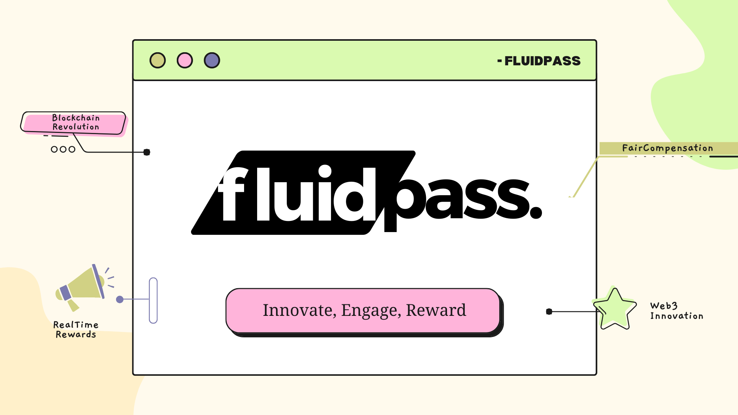

**Images**: Image folder

Here is the homepage of our website: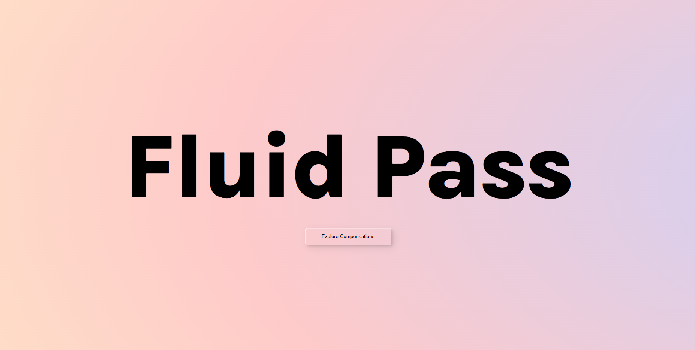

All the available events can be explored through this page:

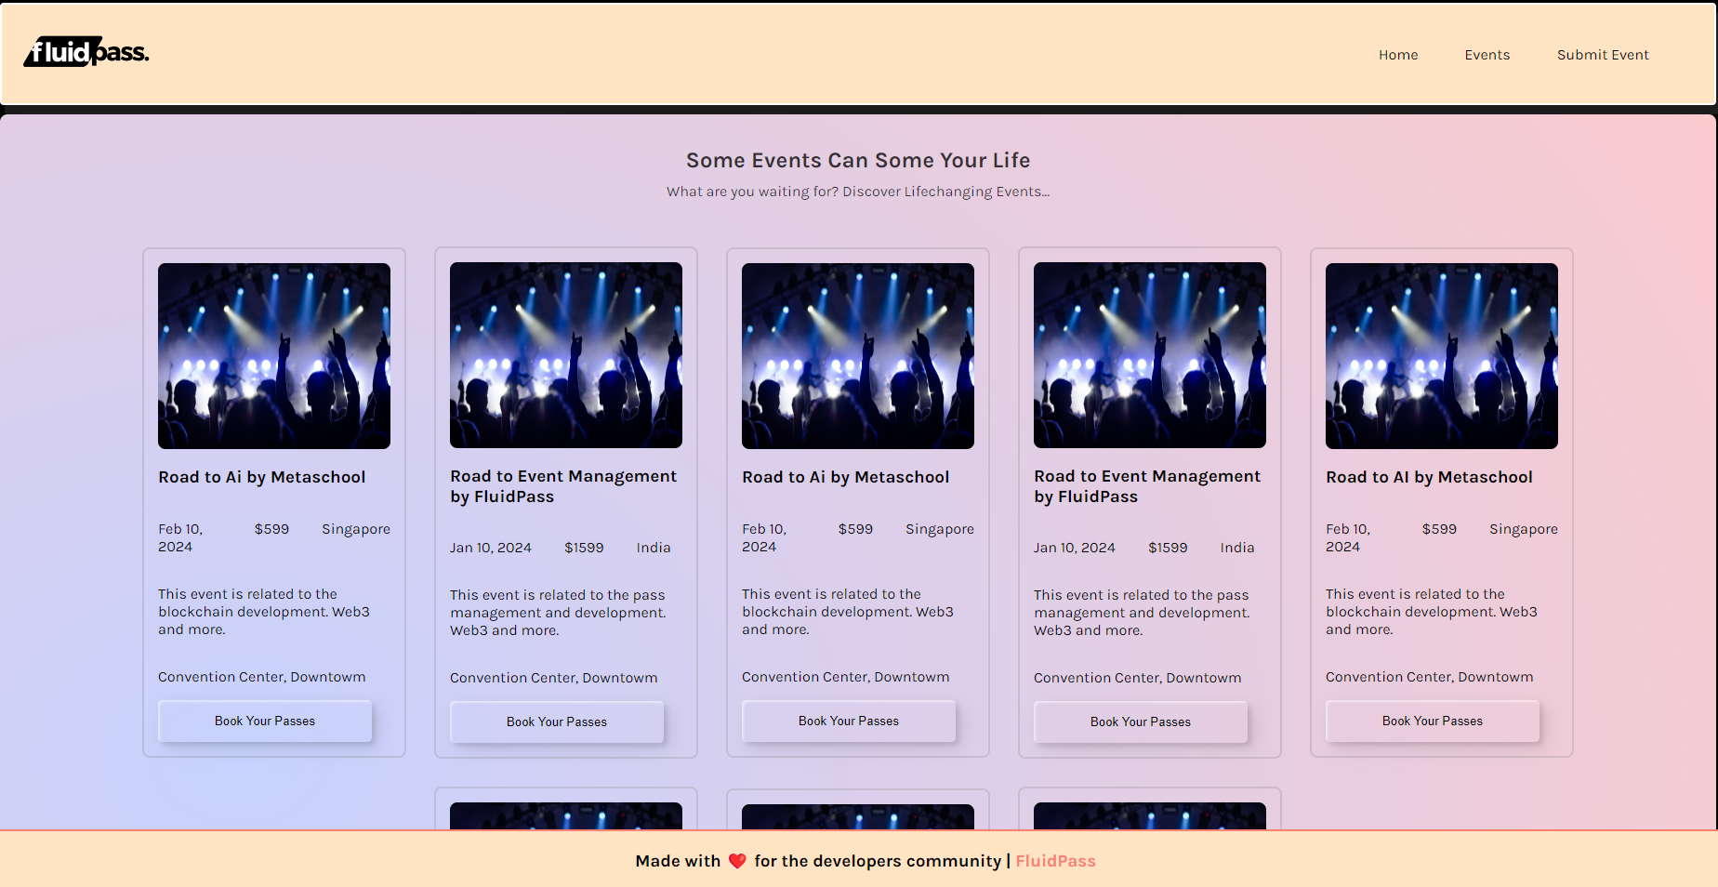

User needs to connect their wallet to book their pass for any event:

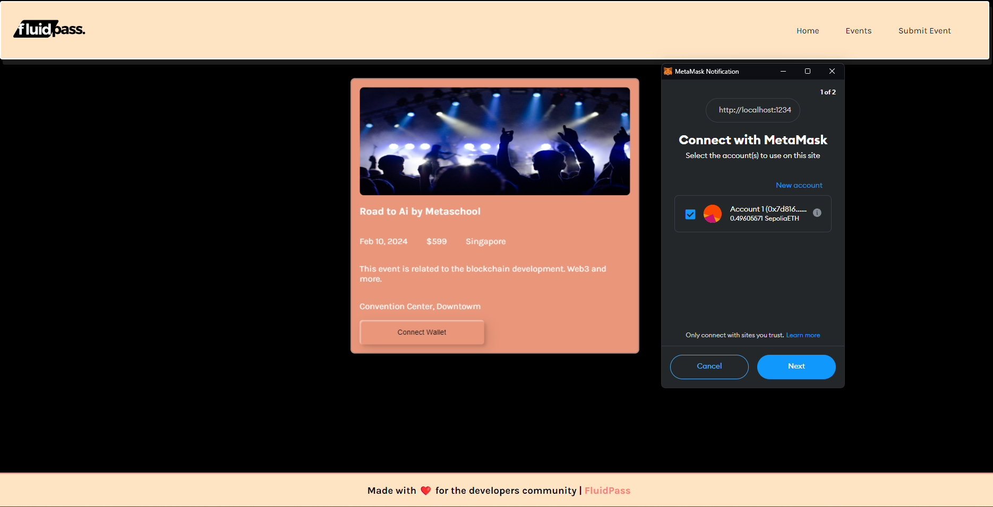

Upon Connecting their wallet user can provide their information and book the event pass:

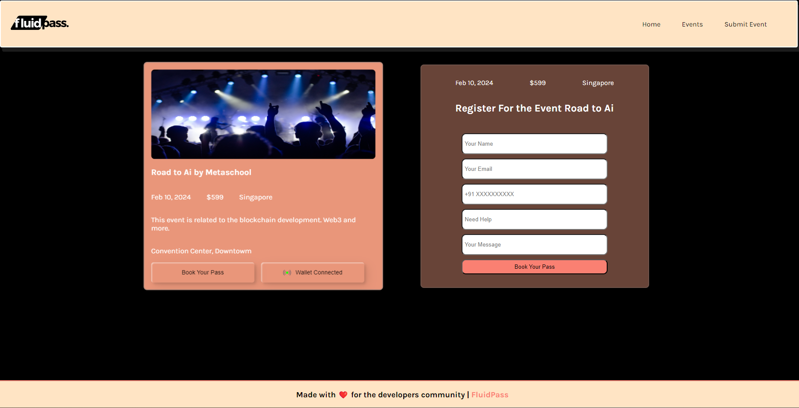

Upon clicking book my pass, create flow function is called that executes the transaction.

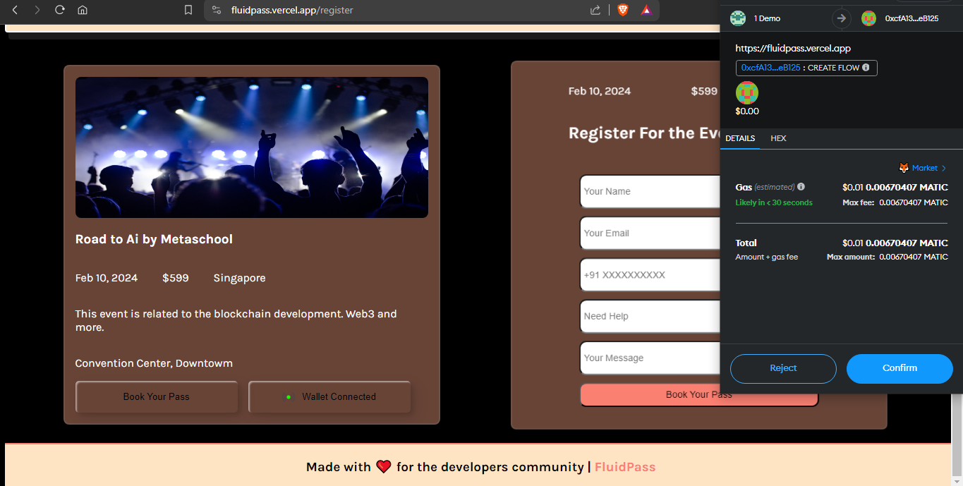

**Video**:

1. [Metablockers Presents Fluidpass](https://www.youtube.com/watch?v=4KLNw7OUTSk)
2. [Website Walkthrough](https://www.loom.com/share/2086278589d1412da1477d5af6ed9b96?sid=90f2330d-6fca-4c57-a9b6-f0b808b643c9)
3. [Problems & Solutions](https://youtu.be/aEAsRNRAkJo)

**Pitch Deck:** [Link for the Presentation](https://www.canva.com/design/DAF7lPNtBR0/Mf-4eCDQOvIpYch_PTZ4hw/view?utm_content=DAF7lPNtBR0&utm_campaign=designshare&utm_medium=link&utm_source=editor)

**Website**: [FluidPass](https://fluidpass.vercel.app/)

**Requirements:**

You will require fake DAI tokens to execute the transaction.

Link for DAI token - <https://tr228g.csb.app/>

Video - [DAI token by MetaBlockers](https://www.loom.com/share/884927380a6e457998a04a22033013e7?sid=aaba615e-e4f1-45e0-a7e4-3cf65a7b60eb)

**Description**:

This project aims to provide a seamless and transparent way to compensate event participants or attendees, ensuring a fair and dynamic payment model. The following are the main features of FluidPass:

**Real-time Payments:** FluidPass allows for instant payments as users engage with an event. Payments are streamed in real time, providing a fluid and efficient compensation mechanism.

**Transparency:** The use of the Superfluid protocol ensures transparency in payment transactions. All transactions can be easily tracked and verified on the blockchain.

**Flexibility:** FluidPass is designed to be flexible and can be integrated into various types of events, including concerts, conferences, live streams, and more.

**Tech Stack**:

* Solidity
* Next.js
* EtherJs Library
* Node.js
* Polygon Blockchain
* Superfluid SDK
* React.js - Frontend

**Team Member Names**:

* Ashish Kumar Sahoo - <https://github.com/Ashish-Kumar-007>
* Debasish Roy - <https://github.com/DRoy01>
* Mark Kamau - <https://github.com/BigmanMKG>
* Nitin Joshi - <https://github.com/highnitin>

**Individual Contribution Breakdown:**

* Ashish Sahoo: Frontend, Smart Contract Development
* Debasish Roy: Frontend, Smart Contract Development
* Mark Kamau: Backend, Data Analysis
* Nitin Joshi: Frontend, Brand Strategies

